**Stock Price and News Sentiment Analysis**

***By Anuj, Archita and Dimple (Mandelbulb Technologies)***

***Project Overview***

Our project is a real-time analytics platform that tracks US news events and their impact on stocks. Using advanced NLP algorithms, it analyzes news articles and social media posts to gauge market sentiment, empowering investors to make informed trading decisions.

This project aims to analyze the sentiment of US news related to 10 US stocks and potentially correlate it with the stock prices. It is divided into two phases:

**Phase 1: Stock Price Data Ingestion**

* 1. Data Source: Twelve Data API (<https://twelvedata.com>)
* Twelve Data offers a programmatic interface (API) for accessing various financial data, including real-time and historical stock prices.
* You'll need to sign up for a Twelve Data account and obtain an API key to access their service.
* The API allows you to specify the stocks you're interested in and the desired data points (e.g., opening price, closing price, volume).
  1. Data Fetching: Azure Logic Apps
* Azure Logic Apps is a cloud-based service for automating workflows by connecting to various Azure services and third-party APIs.
* In this phase, you'll create a Logic App that:
* Triggers at regular intervals (e.g., every hour) using a built-in scheduler.
* Uses an HTTP connector action to call the Twelve Data API with the desired stock information.
* Parses the response from the API to extract the relevant stock price data.

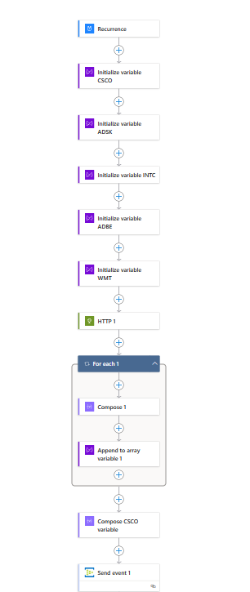

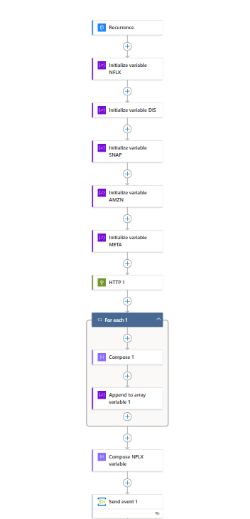

* 1. Data Streaming: Event Hub (Azure)
* Event Hub is a highly scalable real-time data ingestion service in Azure.
* It acts as a buffer, decoupling data producers (Logic Apps) from data consumers (KQL database) and handling high volumes of data streams.
* The Logic App will send the fetched stock price data as events to the configured Event Hub in your Azure subscription.

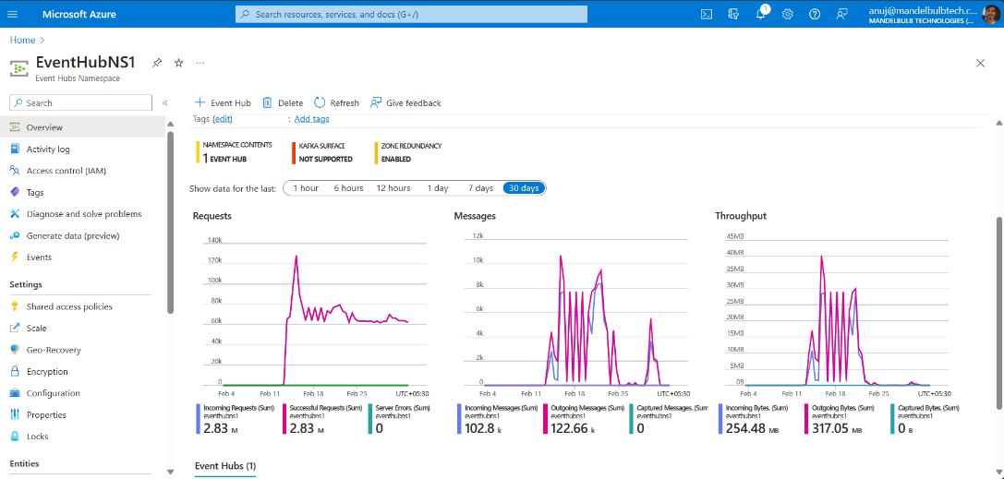

* 1. Data Storage: KQL Database (Azure)
* KQL Database, powered by Kusto Query Language (KQL), is a service optimized for storing, analyzing, and visualizing large volumes of time-series data.
* The streamed stock price data from the Event Hub is ingested into the KQL database.
* You can use KQL to efficiently query, analyze, and visualize the historical stock price data for further insights.

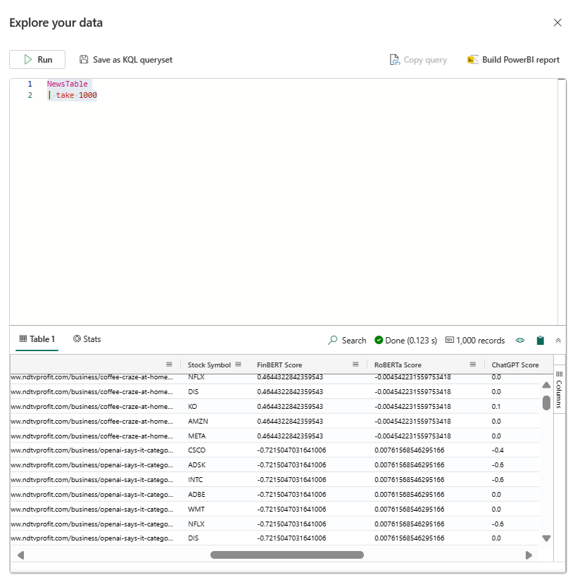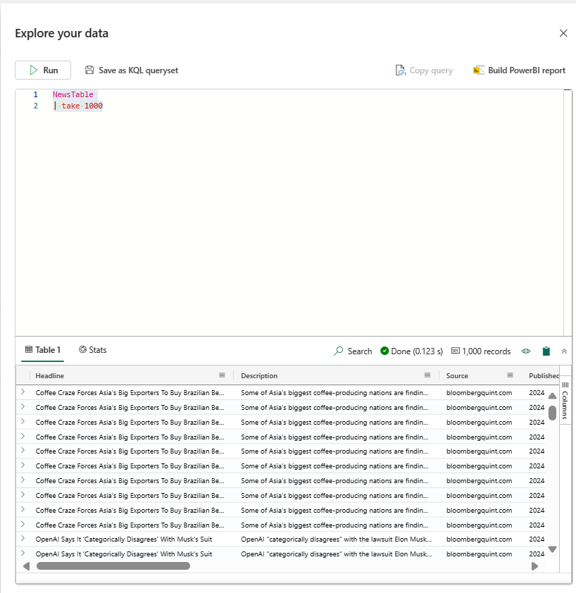

**Phase 2: News Sentiment Analysis and Integration**

2.1. Data Source: MarketAux API ([https://marketaux.com])

* MarketAux provides an API for accessing real-time and historical market news.
* Similar to Twelve Data, you'll need a MarketAux API key to retrieve relevant news articles.
* You can configure the API to filter news based on keywords related to the 10 US stocks you're tracking.

2.2. Data Processing: Python notebook in Microsoft Fabric

* Microsoft Fabric is a platform for developing and deploying dataflows.
* In this project, you'll create a Python notebook that runs within the Fabric environment.
* The notebook will:
  + Use Python libraries to interact with the MarketAux API.
  + Fetch news articles relevant to the tracked stocks based on the configured keywords.

2.3. Sentiment Analysis Tools:

* Sentiment analysis involves determining the emotional tone (positive, negative, or neutral) of a text piece.
* This project utilizes three different tools for a more comprehensive analysis:
* finBERT: This pre-trained model is specifically designed for understanding financial text, potentially offering better accuracy for news related to stocks.
* RoBERT: A robust general-purpose model trained on a massive dataset of text and code, offering a broader understanding of language.
* OpenAI (ChatGPT): A large language model known for its ability to interpret complex language nuances, potentially providing additional insights.2.4. Score Combination:
* Each sentiment analysis tool assigns a score (positive, negative, or neutral) to each news article.
* This project employs a weighted average to combine the scores from different tools:
  + finBERT: 20% weight - Capitalizes on its financial text expertise.
  + RoBERT: 20% weight - Leverages its general understanding of language.
  + OpenAI: 60% weight - Places greater emphasis on its ability to capture subtle nuances.

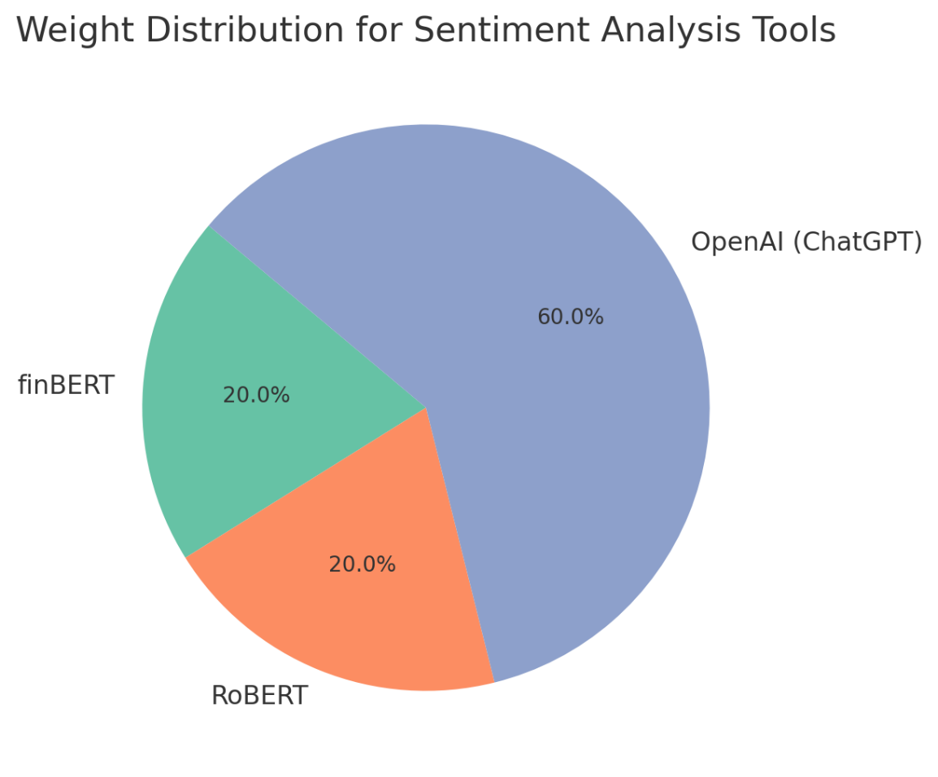

2.5. Data Sending: Custom App in Microsoft Fabric

* A custom app developed within Microsoft Fabric is responsible for sending the combined sentiment score for each news article.
* This custom app likely utilizes Python libraries to format and send the data efficiently.

2.6. Data Storage: KQL Database (Azure)

* The combined sentiment scores, along with timestamps, are streamed into the KQL database alongside the corresponding stock price data.
* This allows you to analyze and potentially identify correlations between news sentiment and stock price movements.

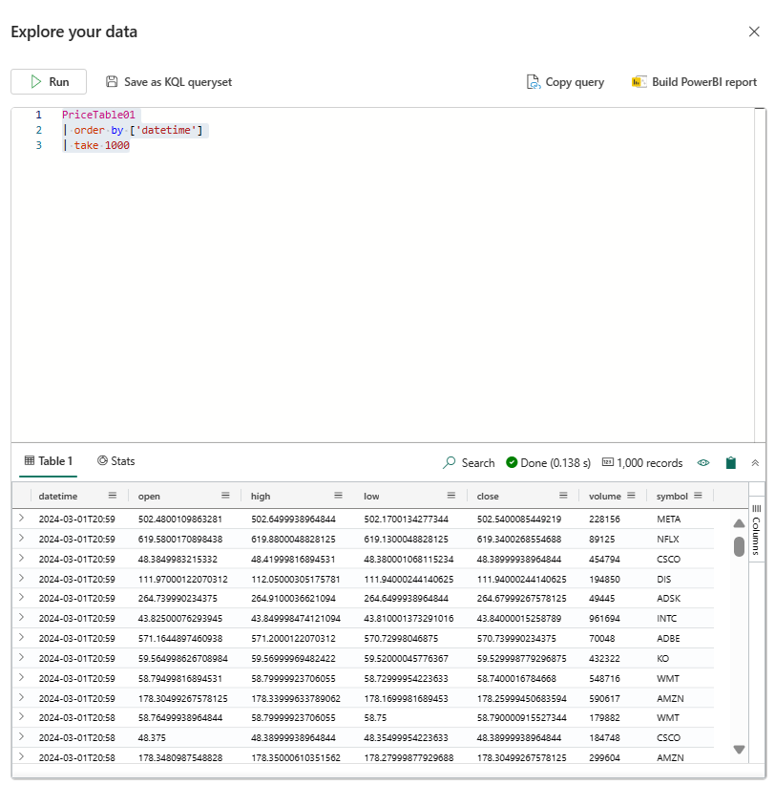

**Further Analysis and Applications**

* The combined sentiment data and stock prices can be used for various analyses, including:
* Exploring potential correlations between news sentiment and stock price movements.
* Identifying news events that may have a significant impact on specific stocks.
* Building machine learning models to predict stock price trends based on sentiment analysis.

**Tools and Technologies**

* Twelve Data API
* Azure Logic Apps
* Azure Event Hub
* KQL Database
* Microsoft Fabric
* Python
* finBERT
* RoBERT
* OpenAI (ChatGPT)